function [p] = SMO_Kolmogorov

l = 1; % Интенсивность поступления заявок

mu = 1; % Интенсивность обслуживания

dt = 0.01; % Шаг по времени

T = 10; % Общее время моделирования

N = T / dt; % Количество шагов по времени

M = 12; % Число состояний (P0 ... P11)

A = [...

-l mu 0 0 0 0 0 0 0 0 0 0;

l -(l+mu) 2*mu 0 0 0 0 0 0 0 0 0;

0 l -(l+2*mu) 3*mu 0 0 0 0 0 0 0 0;

0 0 l -(l+3*mu) 4*mu 0 0 0 0 0 0 0;

0 0 0 l -(l+4*mu) 5*mu 0 0 0 0 0 0;

0 0 0 0 l -(l+5*mu) 5*mu 0 0 0 0 0;

0 0 0 0 0 l -(l+5*mu) 5*mu 0 0 0 0;

0 0 0 0 0 0 l -(l+5*mu) 5*mu 0 0 0;

0 0 0 0 0 0 0 l -(l+5*mu) 5*mu 0 0;

0 0 0 0 0 0 0 0 l -(l+5*mu) 5*mu 0;

0 0 0 0 0 0 0 0 0 l -(l+5*mu) 5*mu;

0 0 0 0 0 0 0 0 0 0 l -5*mu

];

p = zeros(N, M);

t = (0:N-1)' * dt;

p(1,:) = [1, zeros(1, M-1)]; % Начальные условия

% Метод Эйлера

for i = 2:N

p(i,:) = p(i-1,:) + dt * (p(i-1,:) * A);

end

% Построение графиков

styles = {'-', '--', ':', '-.', '-', '--', ':', '-.', '-', '--', ':', '-.'};

figure;

hold on;

for j = 1:M

plot(t, p(:,j), styles{j}, 'LineWidth', 1.5);

end

hold off;

title('Вероятности P_0...P_{11}', 'FontName', 'Arial Unicode MS');

xlabel('t');

ylabel('P');

legend(arrayfun(@(k) sprintf('P_{%d}', k), 0:M-1, 'UniformOutput', false), 'Location', 'eastoutside');

grid on;

end

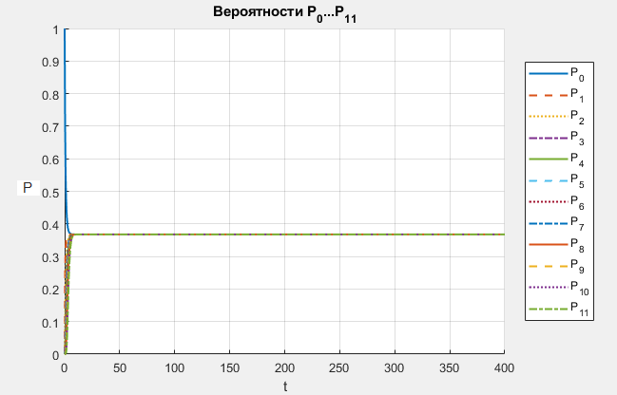

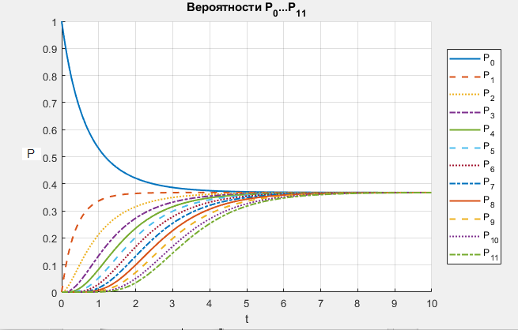

function [p, n, Ms, Mz, r, Potk, lotk, q, A_abs, Dneobsl, Dotk, t_s, toq, tobs, W] = SMO_Kolmogorov_raschet;

% Параметры

l = 1;

mu = 1;

dt = 0.01;

T = 40;

N = T/dt;

M = 12;

% Матрица A

A = [...

-l mu 0 0 0 0 0 0 0 0 0 0;

l -(l+mu) 2*mu 0 0 0 0 0 0 0 0 0;

0 l -(l+2*mu) 3*mu 0 0 0 0 0 0 0 0;

0 0 l -(l+3*mu) 4*mu 0 0 0 0 0 0 0;

0 0 0 l -(l+4*mu) 5*mu 0 0 0 0 0 0;

0 0 0 0 l -(l+5*mu) 5*mu 0 0 0 0 0;

0 0 0 0 0 l -(l+5*mu) 5*mu 0 0 0 0;

0 0 0 0 0 0 l -(l+5*mu) 5*mu 0 0 0;

0 0 0 0 0 0 0 l -(l+5*mu) 5*mu 0 0;

0 0 0 0 0 0 0 0 l -(l+5*mu) 5*mu 0;

0 0 0 0 0 0 0 0 0 l -(l+5*mu) 5*mu;

0 0 0 0 0 0 0 0 0 0 l -5*mu

];

% Начальные условия

p = zeros(N, M);

p(1,1) = 1;

% Решение

for t = 2:N

p(t,:) = p(t-1,:) + dt * (p(t-1,:) * A);

end

% Расчёты

time = (0:N-1)*dt;

n = zeros(N,1); Ms = zeros(N,1); Mz = zeros(N,1); r = zeros(N,1);

Potk = zeros(N,1); lotk = zeros(N,1); q = zeros(N,1); A_abs = zeros(N,1);

Dneobsl = zeros(N,1); Dotk = zeros(N,1); t_s = zeros(N,1);

toq = zeros(N,1); tobs = zeros(N,1); W = zeros(N,1);

C1 = 100; C2 = 10; C3 = 20; C4 = 15;

for i = 1:N

pi = p(i,:);

n(i) = sum((0:11) .* pi);

Ms(i) = 6*pi(1) + 5*pi(2) + 4*pi(3) + 3*pi(4) + 2*pi(5) + pi(6);

Mz(i) = 6 - Ms(i);

r(i) = 0*pi(1) + 0*pi(2) + 0*pi(3) + 0*pi(4) + 0*pi(5) + 0*pi(6) + pi(7) + 2*pi(8) + 3*pi(9) + 4*pi(10) + 5*pi(11) + 6*pi(12);

Potk(i) = pi(12);

lotk(i) = l * Potk(i);

q(i) = 1 - Potk(i);

A_abs(i) = q(i) * l;

Dneobsl(i) = lotk(i) / l;

Dotk(i) = Dneobsl(i);

t_s(i) = n(i) / A_abs(i);

toq(i) = r(i) / A_abs(i);

tobs(i) = t_s(i) - toq(i);

W(i) = C1*Mz(i) + C2*r(i) + C3*lotk(i) - C4*A_abs(i);

end

data = [n Ms Mz r Potk lotk q A_abs Dneobsl Dotk t_s toq tobs W];

% Построение графиков

titles = {'n','Ms','Mz','r','P_{отк}','λ_{отк}','q','A','D_{необсл}','D_{отк}','t_{с}','t_{оч}','t_{обс}','W'};

figure;

for i = 1:6

subplot(2,3,i);

plot(time, data(:,i), 'LineWidth', 1.5);

title(titles{i}); xlabel('t'); ylabel(titles{i});

end

figure;

for i = 7:14

subplot(3,3,i-6);

plot(time, data(:,i), 'LineWidth', 1.5);

title(titles{i}); xlabel('t'); ylabel(titles{i});

end

end

[p, n, Ms, Mz, r, Potk, lotk, q, A, Dneobsl, Dotk, t_s, toq, tobs, W] = SMO_Kolmogorov_raschet;

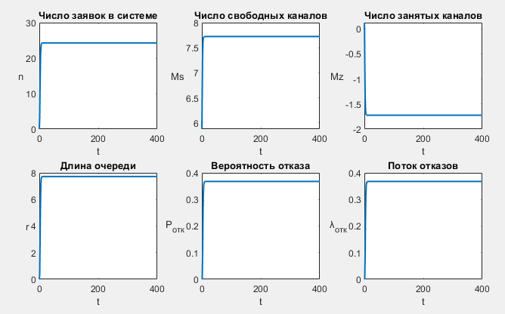

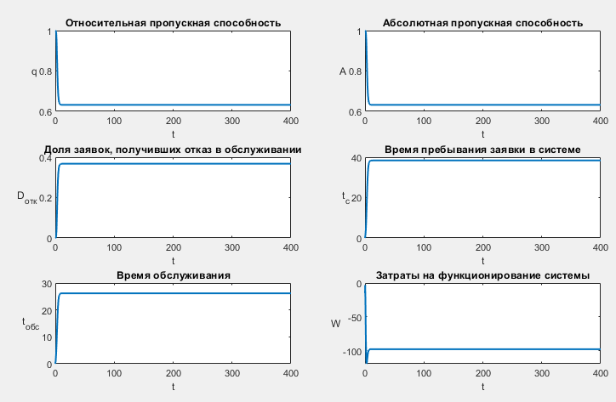

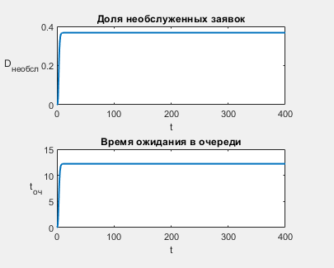

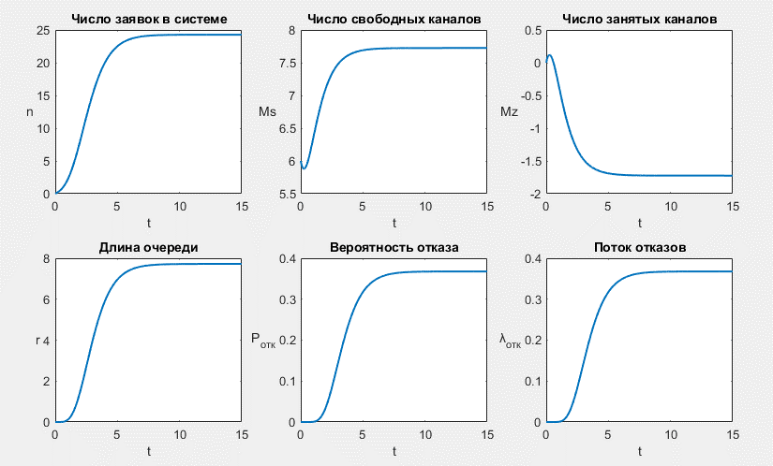

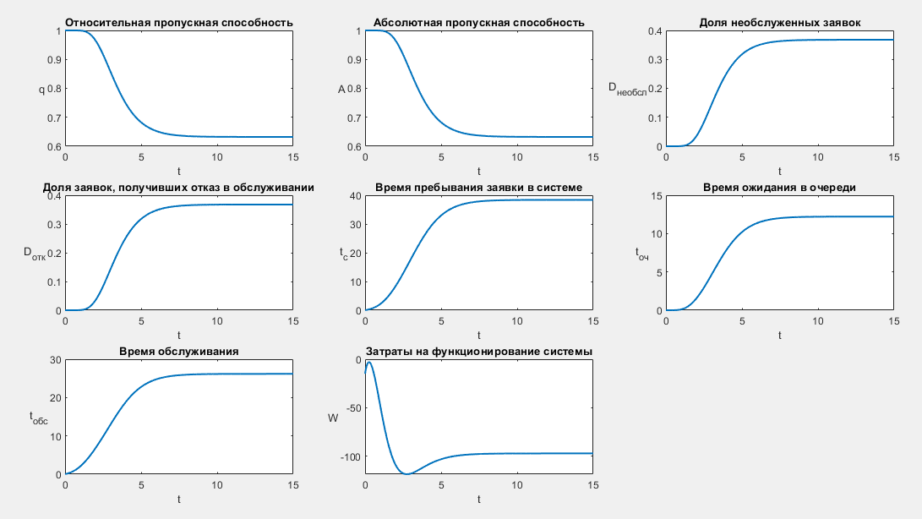

|  |  |  |  |  |  |  |  |
| --- | --- | --- | --- | --- | --- | --- | --- |
| t | n | Мс | Мз | r | Pотк | Dнеобсл | Dотк |
| 1 | 2,128 | 6,334 | -0,334 | 0,102 | 0,000 | 0,000 | 0,000 |
| 2 | 7,977 | 7,095 | -1,095 | 1,463 | 0,034 | 0,034 | 0,034 |
| 3 | 15,076 | 7,476 | -1,476 | 3,945 | 0,143 | 0,143 | 0,143 |
| 4 | 19,991 | 7,630 | -1,630 | 5,904 | 0,252 | 0,252 | 0,252 |
| 5 | 22,491 | 7,689 | -1,689 | 6,953 | 0,317 | 0,317 | 0,317 |
| 6 | 23,576 | 7,711 | -1,711 | 7,419 | 0,347 | 0,347 | 0,347 |
| 7 | 24,010 | 7,719 | -1,719 | 7,608 | 0,360 | 0,360 | 0,360 |
| 8 | 24,176 | 7,722 | -1,722 | 7,680 | 0,365 | 0,365 | 0,365 |
| 9 | 24,239 | 7,723 | -1,723 | 7,708 | 0,367 | 0,367 | 0,367 |
| 10 | 24,262 | 7,724 | -1,724 | 7,718 | 0,367 | 0,367 | 0,367 |
| 11 | 24,271 | 7,724 | -1,724 | 7,722 | 0,368 | 0,368 | 0,368 |
| 12 | 24,274 | 7,724 | -1,724 | 7,723 | 0,368 | 0,368 | 0,368 |
| 13 | 24,275 | 7,724 | -1,724 | 7,724 | 0,368 | 0,368 | 0,368 |
| 14 | 24,276 | 7,724 | -1,724 | 7,724 | 0,368 | 0,368 | 0,368 |
| 15 | 24,276 | 7,724 | -1,724 | 7,724 | 0,368 | 0,368 | 0,368 |
| 16 | 24,276 | 7,724 | -1,724 | 7,724 | 0,368 | 0,368 | 0,368 |
| 17 | 24,276 | 7,724 | -1,724 | 7,724 | 0,368 | 0,368 | 0,368 |
| 18 | 24,276 | 7,724 | -1,724 | 7,724 | 0,368 | 0,368 | 0,368 |
| 19 | 24,276 | 7,724 | -1,724 | 7,724 | 0,368 | 0,368 | 0,368 |
| 20 | 24,276 | 7,724 | -1,724 | 7,724 | 0,368 | 0,368 | 0,368 |
| 21 | 24,276 | 7,724 | -1,724 | 7,724 | 0,368 | 0,368 | 0,368 |
| 22 | 24,276 | 7,724 | -1,724 | 7,724 | 0,368 | 0,368 | 0,368 |
| 23 | 24,276 | 7,724 | -1,724 | 7,724 | 0,368 | 0,368 | 0,368 |
| 24 | 24,276 | 7,724 | -1,724 | 7,724 | 0,368 | 0,368 | 0,368 |
| 25 | 24,276 | 7,724 | -1,724 | 7,724 | 0,368 | 0,368 | 0,368 |
| 26 | 24,276 | 7,724 | -1,724 | 7,724 | 0,368 | 0,368 | 0,368 |
| 27 | 24,276 | 7,724 | -1,724 | 7,724 | 0,368 | 0,368 | 0,368 |
| 28 | 24,276 | 7,724 | -1,724 | 7,724 | 0,368 | 0,368 | 0,368 |
| 29 | 24,276 | 7,724 | -1,724 | 7,724 | 0,368 | 0,368 | 0,368 |
| 30 | 24,276 | 7,724 | -1,724 | 7,724 | 0,368 | 0,368 | 0,368 |
| 31 | 24,276 | 7,724 | -1,724 | 7,724 | 0,368 | 0,368 | 0,368 |
| 32 | 24,276 | 7,724 | -1,724 | 7,724 | 0,368 | 0,368 | 0,368 |
| 33 | 24,276 | 7,724 | -1,724 | 7,724 | 0,368 | 0,368 | 0,368 |
| 34 | 24,276 | 7,724 | -1,724 | 7,724 | 0,368 | 0,368 | 0,368 |
| 35 | 24,276 | 7,724 | -1,724 | 7,724 | 0,368 | 0,368 | 0,368 |
| 36 | 24,276 | 7,724 | -1,724 | 7,724 | 0,368 | 0,368 | 0,368 |
| 37 | 24,276 | 7,724 | -1,724 | 7,724 | 0,368 | 0,368 | 0,368 |
| 38 | 24,276 | 7,724 | -1,724 | 7,724 | 0,368 | 0,368 | 0,368 |
| 39 | 24,276 | 7,724 | -1,724 | 7,724 | 0,368 | 0,368 | 0,368 |
| 40 | 24,276 | 7,724 | -1,724 | 7,724 | 0,368 | 0,368 | 0,368 |

|  |  |  |  |  |  |  |  |
| --- | --- | --- | --- | --- | --- | --- | --- |
| t | λотк | q | A | tс | tож | tобсл | W |
| 1 | 0,000 | 1,000 | 1,000 | 2,129 | 0,102 | 2,027 | -47,402 |
| 2 | 0,034 | 0,966 | 0,966 | 8,257 | 1,514 | 6,742 | -108,688 |
| 3 | 0,143 | 0,857 | 0,857 | 17,590 | 4,603 | 12,987 | -118,163 |
| 4 | 0,252 | 0,748 | 0,748 | 26,727 | 7,893 | 18,834 | -110,188 |
| 5 | 0,317 | 0,683 | 0,683 | 32,930 | 10,180 | 22,749 | -103,302 |
| 6 | 0,347 | 0,653 | 0,653 | 36,123 | 11,368 | 24,755 | -99,775 |
| 7 | 0,360 | 0,640 | 0,640 | 37,511 | 11,886 | 25,625 | -98,263 |
| 8 | 0,365 | 0,635 | 0,635 | 38,063 | 12,092 | 25,971 | -97,664 |
| 9 | 0,367 | 0,633 | 0,633 | 38,274 | 12,171 | 26,103 | -97,435 |
| 10 | 0,367 | 0,633 | 0,633 | 38,353 | 12,201 | 26,153 | -97,349 |
| 11 | 0,368 | 0,632 | 0,632 | 38,383 | 12,212 | 26,171 | -97,318 |
| 12 | 0,368 | 0,632 | 0,632 | 38,394 | 12,216 | 26,178 | -97,306 |
| 13 | 0,368 | 0,632 | 0,632 | 38,398 | 12,217 | 26,180 | -97,301 |
| 14 | 0,368 | 0,632 | 0,632 | 38,399 | 12,218 | 26,181 | -97,300 |
| 15 | 0,368 | 0,632 | 0,632 | 38,400 | 12,218 | 26,182 | -97,299 |
| 16 | 0,368 | 0,632 | 0,632 | 38,400 | 12,218 | 26,182 | -97,299 |
| 17 | 0,368 | 0,632 | 0,632 | 38,400 | 12,218 | 26,182 | -97,299 |
| 18 | 0,368 | 0,632 | 0,632 | 38,400 | 12,218 | 26,182 | -97,299 |
| 19 | 0,368 | 0,632 | 0,632 | 38,400 | 12,218 | 26,182 | -97,299 |
| 20 | 0,368 | 0,632 | 0,632 | 38,400 | 12,218 | 26,182 | -97,299 |
| 21 | 0,368 | 0,632 | 0,632 | 38,400 | 12,218 | 26,182 | -97,299 |
| 22 | 0,368 | 0,632 | 0,632 | 38,400 | 12,218 | 26,182 | -97,299 |
| 23 | 0,368 | 0,632 | 0,632 | 38,400 | 12,218 | 26,182 | -97,299 |
| 24 | 0,368 | 0,632 | 0,632 | 38,400 | 12,218 | 26,182 | -97,299 |
| 25 | 0,368 | 0,632 | 0,632 | 38,400 | 12,218 | 26,182 | -97,299 |
| 26 | 0,368 | 0,632 | 0,632 | 38,400 | 12,218 | 26,182 | -97,299 |
| 27 | 0,368 | 0,632 | 0,632 | 38,400 | 12,218 | 26,182 | -97,299 |
| 28 | 0,368 | 0,632 | 0,632 | 38,400 | 12,218 | 26,182 | -97,299 |
| 29 | 0,368 | 0,632 | 0,632 | 38,400 | 12,218 | 26,182 | -97,299 |
| 30 | 0,368 | 0,632 | 0,632 | 38,400 | 12,218 | 26,182 | -97,299 |
| 31 | 0,368 | 0,632 | 0,632 | 38,400 | 12,218 | 26,182 | -97,299 |
| 32 | 0,368 | 0,632 | 0,632 | 38,400 | 12,218 | 26,182 | -97,299 |
| 33 | 0,368 | 0,632 | 0,632 | 38,400 | 12,218 | 26,182 | -97,299 |
| 34 | 0,368 | 0,632 | 0,632 | 38,400 | 12,218 | 26,182 | -97,299 |
| 35 | 0,368 | 0,632 | 0,632 | 38,400 | 12,218 | 26,182 | -97,299 |
| 36 | 0,368 | 0,632 | 0,632 | 38,400 | 12,218 | 26,182 | -97,299 |
| 37 | 0,368 | 0,632 | 0,632 | 38,400 | 12,218 | 26,182 | -97,299 |
| 38 | 0,368 | 0,632 | 0,632 | 38,400 | 12,218 | 26,182 | -97,299 |
| 39 | 0,368 | 0,632 | 0,632 | 38,400 | 12,218 | 26,182 | -97,299 |
| 40 | 0,368 | 0,632 | 0,632 | 38,400 | 12,218 | 26,182 | -97,299 |